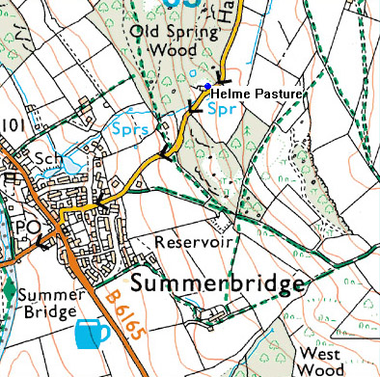
Postal Address:
Helme Pasture,
Hartwith Bank,
Summerbridge
Harrogate
North Yorkshire,
HG3 4DR

Grid Reference: SE 20555 62763

Parking and accommodation location
Stone Croft and Fern Crag:
A large gravel parking area, serving both lodges is situated next to the lodges. Access to the specific lodges is signposted on the lodges themselves.
Farmhouse Studio: Parking is in the layby in front of the main farm house, ensuring vehicular access around the rest of the farmhouse is maintained. The entrance to the Studio is through the main farmhouse front door.
The Byre: Parking is available in the layby at the side of the Byre, below the wrought iron steps. This parking spot is quite steep, so additional parking is also available behind the main farmhouse, accessed from the short drive leading from the road, immediately above the farmhouse. Entrance to the Byre is via the door nearest the road at the front of the farmhouse.
The Old Barn: Parking for the Old Barn is in front of the garage doors, above the wrought iron steps. Additional parking is available at the rear of the main farmhouse, accessed from the short drive leading from the road. The entrance to the Old Barn is via the wrought iron steps at the side of the house next to the garage doors.
Access to the Accommodation
To make things easier for you, please park up in the relevant parking area before getting the key.
The key for Fern Crag, Stone Croft, the Byre and the Old Barn can be located within a key safe next to or very near to each accommodation front door.
The code to open the key safe for your accommodation will have been emailed to you shortly after your final payment was made.
The key for the Studio will be within a security box which is located next to the office entrance porch. This office door is located on the left hand side of the farmhouse, furthest away from the road. After retrieval of the key for the Studio, please ring the main farmhouse doorbell. In most circumstances, Rosemary will be able to meet you on arrival and show you in. If there is no answer, please enter through the main house door and go straight ahead to the back of the hall and turn left into the ‘Studio’.
Please be aware that the hall is a shared area so please keep this external door locked and do not leave your keys in this outer door as no one else will be able to enter. The inner door to the Studio can be locked however you wish.

